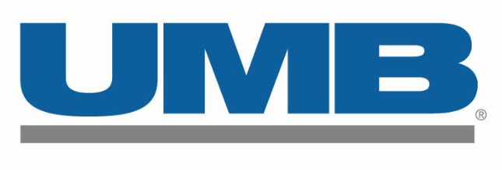

UMB Fund Services News Release
235 W. Galena St.
Milwaukee, WI 53212

For more information please contact:

Kaele Palmer, 202.276.2471

kaele.palmer@umb.com

Farnam Street Real Estate Capital Selects UMB Fund Services to Administer New Private Fund

OMAHA, Neb. (Jan. 13, 2022) – UMB Fund Services (UMBFS), a subsidiary of UMB Financial Corporation (Nasdaq: UMBF), is pleased to announce that it has been selected to provide fund accounting, investor servicing and tax reporting for Farnam Street Real Estate Capital (FSREC). FSREC is a full-service commercial real estate investment firm. FSREC launched its first closed-end fund, Farnam Street Real Estate Capital Partners I, LP, on May 7, 2021.

“We are pleased to support Farnam Street Real Estate Capital with a suite of services for their innovative private fund,” said Jill Calton, executive vice president and director of alternative investments at UMB Fund Services. “We’re excited to work with a fund that promotes and envisions growth and investment in the communities throughout much of UMB Bank’s footprint.”

Founded in Omaha in 1981, The Lund Company—which joined the Cushman & Wakefield Alliance in 2012—serves as a strategic partner for FSREC and provides property management and real estate services.

FSREC is co-sponsored by Dwayne Sieck and Jason Fisher. Sieck is the co-founder, president and CEO of Farnam Street Real Estate Capital. He previously was president and chief operating officer of Mutual of Omaha Bank. Sieck is also currently serving his second three-year term on the Kansas City Federal Reserve Bank Board as a director of the Omaha Federal Reserve Bank branch.

Fisher is the co-founder of Farnam Street Real Estate Capital. He has also served as president of Cushman & Wakefield/The Lund Company since 2010 and has played a critical role in many of Omaha’s significant real estate projects.

In addition to utilizing UMB Fund Services for fund administration, UMB Bank has worked closely with Farnam Street Real Estate Capital on various Treasury, Depository and Institutional Trust Services.

“The newly formed administration relationship between UMB Fund Services and Farnam Street Real Estate Capital showcases the depth and breadth of services that UMB Financial Corporation offers to clients in Omaha and across the bank’s footprint,” said Joel Falk, president of Nebraska at UMB Bank. “Through serving as a valued banking partner in the region, we continue to build our strong relationship with Farnam Street Real Estate Capital as they expand their relationship with UMB by utilizing our institution’s award-winning fund servicing business.”

About Farnam Street Real Estate Capital:
Farnam Street Real Estate Capital (“FSREC”) is a full-service commercial real estate investment firm located in Omaha, Nebraska. FSREC is focused on optimizing returns for their investors with a mix of core, value add, and development investments that create a balanced approach to dividend income and capital appreciation.

For more information, please contact them at 402-393-8811 or visit www.farnamstreetrecap.com.

About UMB:
UMB Financial Corporation (Nasdaq: UMBF) is a financial services company headquartered in Kansas City, Missouri. UMB offers commercial banking, which includes comprehensive deposit, lending and investment services, personal banking, which includes wealth management and financial planning services, and institutional banking, which includes asset servicing, corporate trust solutions, investment banking, and healthcare services. UMB operates branches throughout Missouri, Illinois, Colorado, Kansas, Oklahoma, Nebraska, Arizona and Texas, and serves business and institutional clients nationwide. For more information, visit UMB.com, UMB Blog, UMB Facebook and UMB LinkedIn, or follow us on Twitter at @UMBBank. For information about UMB’s operations, approach and relief measures during the COVID-19 pandemic, please visit more.umb.com/coronavirus/.
###

